Configure gateways on power BI Service

Power BI is a data analysis tool that connects to many data sources. Suppose the data source for Power BI is located in an on-premises location. In that case, the connection from the cloud-based Power BI Service to the on-premises located data source should be created with an application called Gateway. In this article, you will learn what the Gateway is, the types of the gateway, their differences, installing the gateway, and scheduling a data set with that gateway.
An on-premises data gateway is software that you install in an on-premises network. The on-premises data gateway facilitates access to data in that network and acts as a bridge to provide quick and secure data transfer between on-premises data (data that isn't in the cloud) and several Microsoft cloud services. These cloud services include Power BI, PowerApps, Power Automate, Azure Analysis Services, and Azure Logic Apps. By using a gateway, organizations can keep databases and other data sources on their on-premises networks, yet securely use that on-premises data in cloud services.
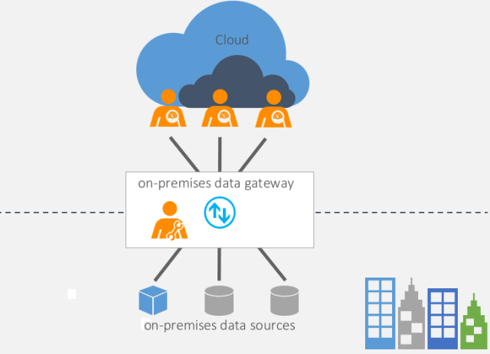

Do you need a gateway always?
You don’t need a gateway in all scenarios, Only if the data source is on-premises. For online or cloud-based data sources, no gateway is required. For example, if you are getting data from CRM Online, you don’t need a gateway. However, if you are getting data from an SQL Server database located on your local domain server, then you need a gateway. For Azure SQL DB, you don’t need a gateway. However, a SQL Server database on Azure Virtual Machine is considered on-premises and needs a gateway.

Types of Gateway
There are three different types of gateways, each for a different scenario:
- On-premises data gateway: Allows multiple users to connect to multiple on-premises data sources. With a single gateway installation, you can use an on-premises data gateway with all supported services. This gateway is well-suited to complex scenarios where multiple people access multiple data sources.
- On-premises data gateway (personal mode): Allows one user to connect to data sources and can’t be shared with others. An on-premises data gateway (personal mode) can only be used with Power BI. This gateway is well-suited to scenarios where you’re the only person who creates reports and you don't need to share any data sources with others.
- Virtual network data gateway: Allows multiple users to connect to multiple data sources secured using virtual networks. No installation is required because it's a Microsoft managed service. This gateway is well-suited to complex scenarios where multiple people access multiple data sources.
But we generally use the Standard on-premises gateway.
Power BI Gateway comes in two modes: Personal mode and standard mode. The difference between these two is not the paid or licensing plan. Both gateways are free to use. The difference is the way that you want to use the gateway. The personal mode is mainly used for one-person use, not for the team. On-premises standard gateway, on the other hand, is a choice when you want to work in a collaborative environment. Let’s look at their differences in detail. In the chart below, the on-premises mode means the standard mode of Power BI on-premises gateway.
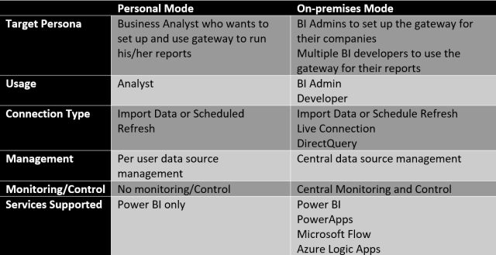
Personal Mode
When you install the gateway in personal mode, you can use it yourself only. You can connect it to local data sources such as SQL Server, Excel, and other data sources. However, the gateway installed in personal mode only supports one type of connection: Import data or schedule refresh. This gateway is only used for Power BI; you cannot use it for other applications.
Because this gateway is personal, you cannot use it in a team development scenario. Multiple developers cannot leverage this gateway. You can create reports and connect them to this gateway and share it with multiple users. However, only one developer can use the gateway. That is why it is named personal mode.
Installing the Personal model and configuring it is easier than the on-premises gateway. When you install the gateway in personal mode, you don’t have the configuration option to set data sources. There is no place to configure it after installation. This gateway mode is meant to be used for business analysts with the least hassle to get their reports published and refreshed.
This type of gateway is usually for one business analyst who wants to publish Power BI reports and schedule them to refresh and share them for users to use easily. Not many configuration options, easy to set up and single developer features make it a good option for such scenarios.
On-premises Standard Mode
Power BI On-premises gateway has a recommended mode to install, which is the standard mode. This mode of installation supports a multi-developer environment. Multiple developers can use the gateway installed. This gateway type is built for team development; you can have a gateway administrator. There is a central configuration section for gateways to add data sources and control them.
On-premises recommended gateway supports not only Power BI but also PowerApps, Azure Logic Apps, and Microsoft Flow, which are other Microsoft cloud-based technologies.
On-premises recommended gateway also supports all types of connections from Power BI. Not only the import data or scheduled refresh is supported, but also DirectQuery and Live Connection are supported with this gateway.
This type of gateway is for enterprise usage of Power BI or where Power BI needs to be used alongside other applications such as PowerApps. Multiple developers can work with the same gateway if the administrator authorizes them to use it. More centralized control and monitoring exist for this type of gateway.
Gateway Execution flow
Here are the details of the architecture of the gateway;
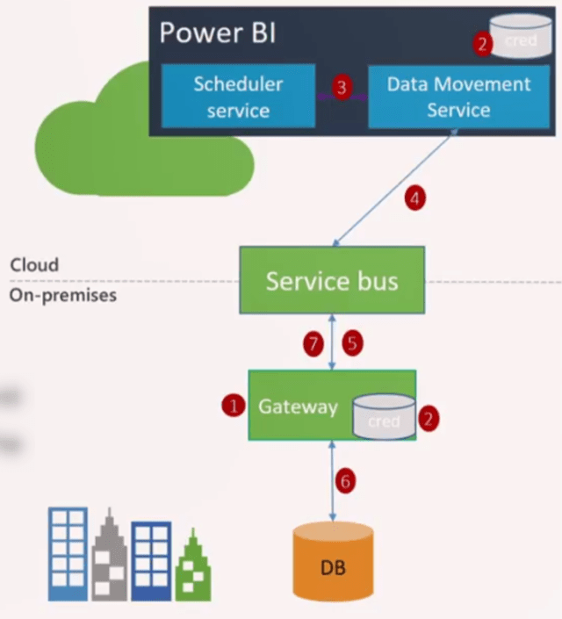
The flow of execution for the Power BI gateway
- Gateway installed on a machine in the on-premises domain. During this installation, credentials are stored in local and Power BI services.
- Credentials entered for the data source in Power BI are encrypted and then stored in the cloud. Only the gateway can decrypt the credentials.
- Power BI service kicks off a dataset refresh; this happens through a Scheduler service in Power BI.
- Data Movement Service analyses the query and pushes it to the appropriate service bus instance.
- There is a queue of requests on the service bus. Gateway pulls the bus for pending requests.
- Gateway gets the query and executes it on the data source.
- After getting the result, the gateway pushes that back to Power BI.

What happens in step 5 is very important. Gateway is pulling the bus to check if there are any pending requests. The bus cannot trigger the gateway. The reason for this architecture is security. If the bus can trigger the gateway, the inbound security ports need to be open, which is not a good practice for security. So, we can say that the gateway connection is very secure because it is only using outbound ports.
Important things to consider before installing the gateway
The gateway can be installed on any machine in the on-premises domain. However, it is not recommended to be installed on the Domain Controller itself. Here are the requirements for gateway installation:
Minimum Requirements:
- .NET Framework 4.7.2 (Gateway release December 2020 and earlier)
- .NET Framework 4.8 (Gateway release February 2021 and later)
- A 64-bit version of Windows 8 or a 64-bit version of Windows Server 2012 R2 with current TLS 1.2 and cipher suites
- 4-GB disk space for performance monitoring logs (in the default configuration)

Recommended:
- An 8-core CPU
- 8 GB of memory
- A 64-bit version of Windows Server 2012 R2 or later
- Solid-state drive (SSD) storage for spooling.

How many gateways are required?
One gateway should be enough for many situations. However, sometimes you would get more benefits from having more gateways. As an example, if you have a gateway that is used for scheduled data refresh, and the same gateway is used for a Live Connection, then you get slow performance for the live connection if there is a scheduled data refresh in process at that time. So, in this scenario, you might consider having one gateway for your Live Connection and another for a scheduled refresh.
The gateway can be installed only on 64bit Windows operating systems.
I recommend choosing the version of the gateway you need on that machine carefully. If this is a server, I highly recommend installing an on-premises standard gateway rather than a personal one.
The gateway machine should always be up and running to cater for data refresh queries.
Do not install the gateway on a machine that is connected through a wireless network. Gateway will perform more slowly in a wireless network.
Ports that need to be open for the gateway are all outbound ports: TCP 443 (default), 5671, 5672, 9350, thru 9354. The gateway does not require inbound ports.

Installing Gateway
You can download Gateway from this link:
https://powerbi.microsoft.com/en-us/gateway/
Or you can find the link when you log in to Power BI service, under download; Data Gateway;
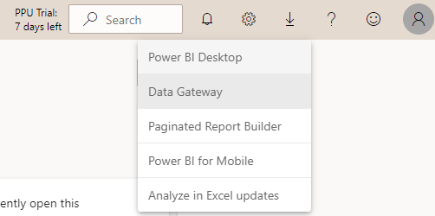Download Power BI Gateway
After running the installation file, you will see the option to choose the gateway type.
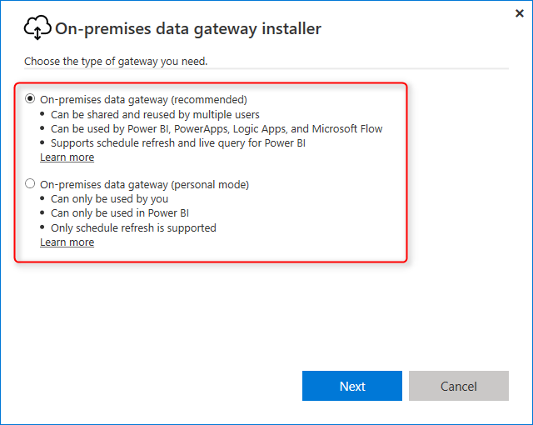
For this example, we are going to install the on-premises recommended gateway option because it supports Live connection and DirectQuery connection, which we will talk about it in other posts.
After choosing the gateway type, the installer downloads the remaining files required for installation, and then you can continue the installation. You need to choose the folder to install the gateway. For this example, we’ll keep the folder with no change. The installation process is simple. After installation, you need to register your gateway.
To register your gateway, you need to use your Power BI email account and then sign in.
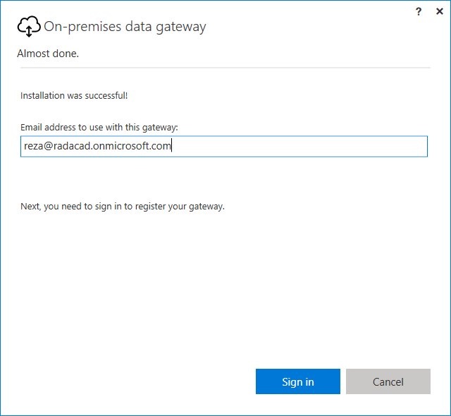
You can then Register a new gateway or migrate or restore an existing gateway.
Select Register a new gateway, and continue. You will need to enter two important pieces of information;
- Gateway name: a name that can remind you where this gateway is installed. For example, Reza-Vaio-Gateway or something like that.
- Recovery Key: this is a very important key required for recovering the gateway later. If you want to uninstall it and install it again, or if you want to move the gateway from one machine to another without the hassle of changing all connections, then keep the gateway name and recovery key in a safe place.
- You can also add the gateway to an existing gateway cluster. This option is for having high availability through gateways. For this example, leave that unchecked.
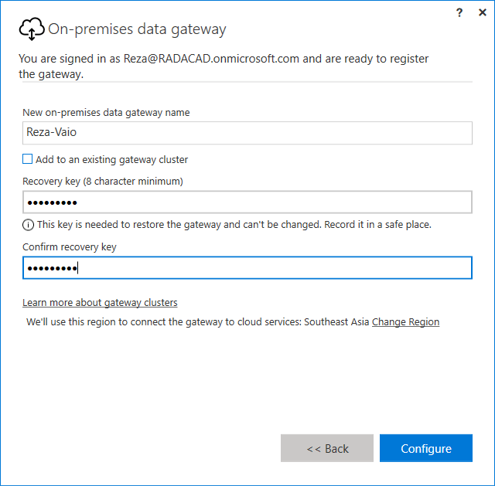
After successful registrations of your gateway, you should see a message that says the gateway is online and ready to go.
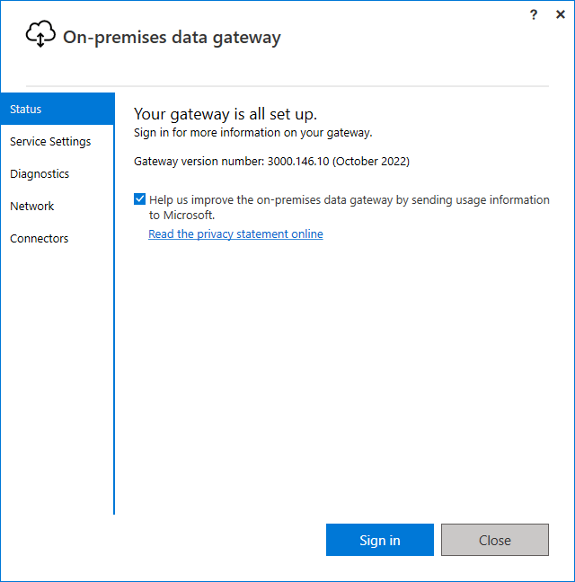Power BI On-premises gateway status
Now you can see the gateway in the Power BI service under your account as well. In Power BI Service, click on Setting Icon, and then click on Manage Gateways.
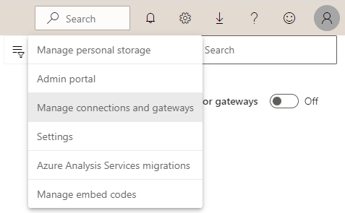Manage gateways from the Power BI Service
You should see all gateways set up under your account. In the screenshot below, you can see that I have a few gateways under my account.
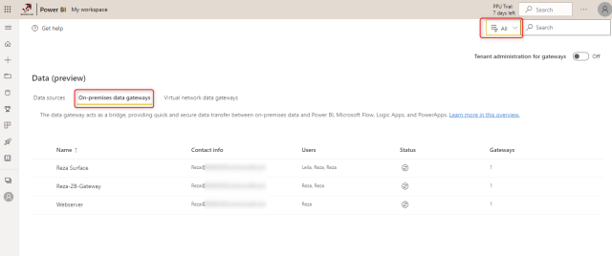Managing gateways in the Power BI service
If you are the tenant administrator, you can turn the “Tenant administration for gateways” on and see and manage all gateways under your organization’s tenant, even if you are not the direct administrator of that gateway.
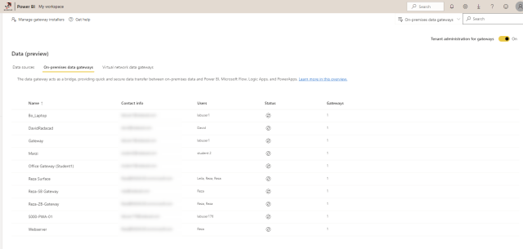Seeing all Power BI gateways under the tenant
Adding Data Sources
The gateway itself is just for creating the connection from the cloud to the local domain. For your datasets to refresh through this gateway, you need to add Data Sources. Data sources are connections to every on-premises database, file, folder, etc., used in Power BI as a connection.
To add data sources to the gateway, first, you need to check the Power BI file and see what data sources have been used. One easy way of finding that out is to open the *.pbix file in the Power BI Desktop.
After opening the file, then you click on Edit Queries -> Data Source Settings.
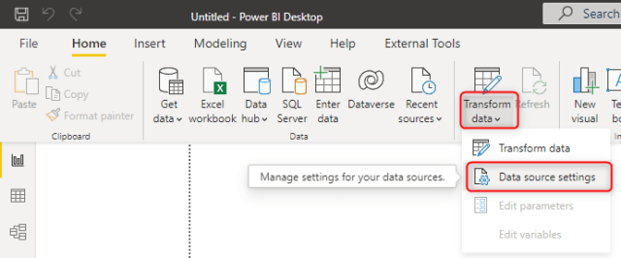Data Source Settings in the Power BI Desktop
In the Data Source Settings, you will see all data sources used in the current file. Click on every data source, click on Change Source, and copy the path for the file.
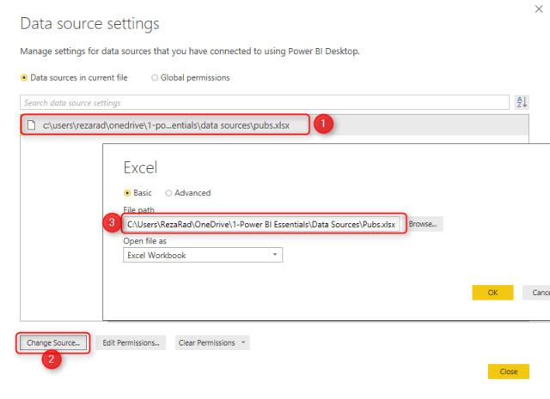
Now you can go to Power BI Service, Manage Gateway section, select the gateway we installed previously, and then click Add Data Source.
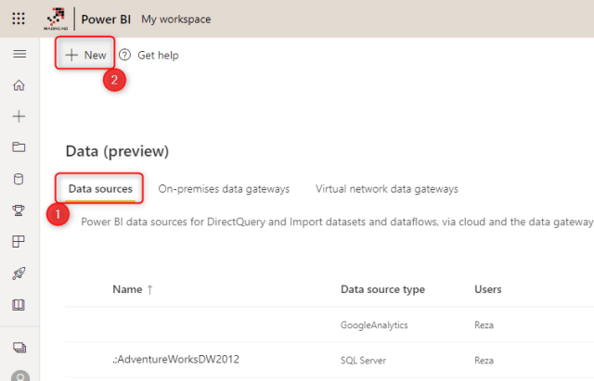Adding a data source
In Add Data Source tab, you need to set some options. The name of the data source is only important for remembering it later easily. The first important option is; Data Source Type. In this example, I choose File because my source is an excel file. However, this can be an SQL Server database or any other data source.
After choosing the data source type, you need to enter other configurations for that source. We have used the file, so we need to specify the full path of the file. This path should be the path of the file from the machine that the gateway is installed on it. If the file is in a shared folder path, then that path should be accessible from the machine that the gateway is installed on it. And this should also be the same path that has been used in the data source configuration of Power BI Desktop.
You need to enter a username and password to access the data source as well. In this case, because we have used a file, the username and password should be the local username and password that have access to that data source from the machine the gateway is installed on. The username should always have a domain name leading it (domain\username), like the screenshot below.
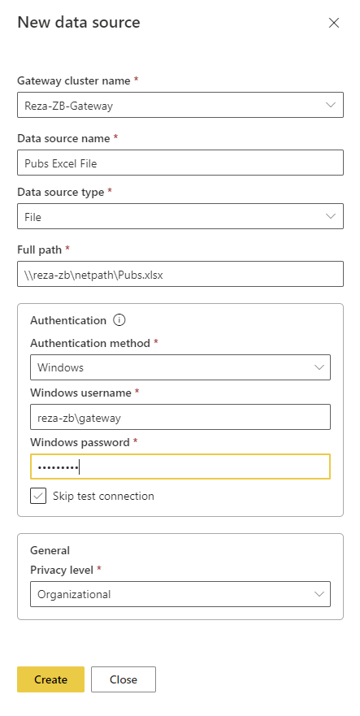
If everything is set up correctly, you should see a message that mentions the Connection Successful.
Important note: If you have multiple sources, then you must do this process for every single one of them.
Set up a Gateway Connection to The Dataset
After adding the required data sources, you can create the connection through the gateway. You should select the data source to configure the Power BI Service. You can go to the Setting of the dataset in Power BI Service.
Click on Gateway Connection. If your gateway has all data sources needed for this dataset, you will see it under Use a data gateway, and you can select it, then click on Apply.
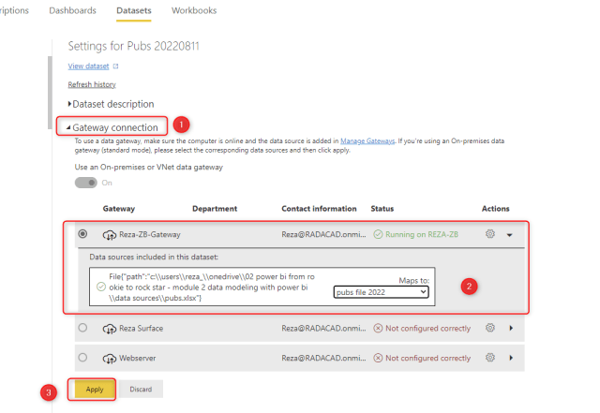mapping the gateway’s data source to the dataset
You have now configured your dataset to refresh through this gateway. You can now test it by manually refreshing your dataset. To manually refresh your dataset, first, find it in your workspace.
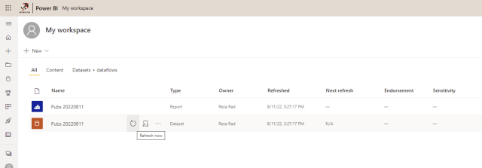Test the refresh of the Power BI dataset
After finding your dataset, then you can click on refresh. The last refresh time should update with no error if everything is set up correctly. Congratulations! You have set up the gateway for your dataset.
Users and Access Controls for Gateway
There are multiple levels of controls on user access when it comes to gateway setup in Power BI.
Gateway installers
By default, anyone in your organization can install a gateway (they would need a Power BI account). However, as the tenant administrator, you can control this by clicking on Manage gateway Installers.
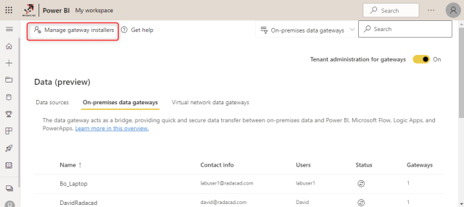Managing the Gateway installers in the organization
When you turn on this option, you can choose the group or people who can install gateways;
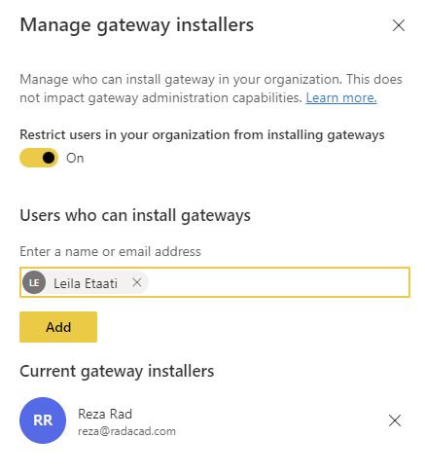
This is good for organizations with many Power BI users, and the control of the installation of the gateway is better to be governed.
Gateway users
Each gateway can have three types of access for the users.
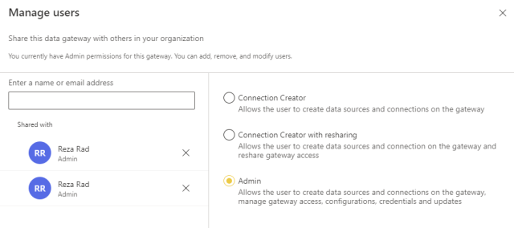User access to the Power BI gateway
Gateway Connection Creator
This type of user can create data sources under the gateway and use them for a connection to the datasets and dataflows.
Gateway Connection Creator with resharing
In addition to creating data sources and using them in connections, this user can also reshare access to the gateway.
Gateway Admin
This user has full control of the gateway. In addition to adding and removing data sources, this user can manage access to the gateway, control the settings, and remove the gateway.
Data Source users
In addition to giving access at the gateway level. You can give users access at the data source level. This is more granular access and is helpful when a user only needs permission or access to a few data sources and not the entire data sources under the gateway. The data source users can also have three types of access;
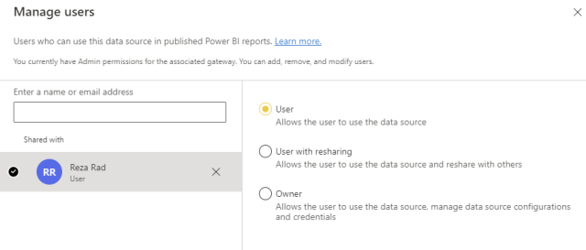Data source users in Power BI gateway
- User; This is just a pure user of the data source. This user cannot change the data source defined under the gateway but can use it to connect to a Power BI dataset or dataflow etc.
- User with resharing; In addition to being the user, this user can also reshare this data source with other users.
- Owner; This user has full control of the data source itself but not of other data sources or the gateway.
You must understand the difference between Data Source users and Gateway users and give access to the users correctly for their use-case. Too much access can sometimes be challenging for a user not trained to use it with caution.
Additional Settings for Gateway
There are a few other important additional settings for the gateway. Here is an explanation of each;
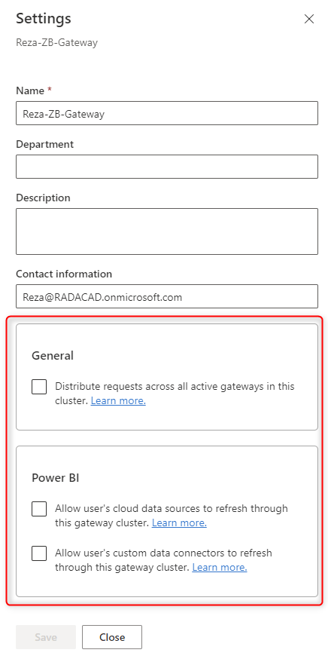Additional settings for Power BI gateways
Distribute requests across all active gateways in this cluster
This means load balancing on the gateways. This is very helpful if the gateway is under many parallel requests. When you set up a gateway cluster (a group of gateway installations bundled together to serve as one gateway), Then you can enable this functionality. To learn more about load balancing, read here.
Allow user’s cloud data sources to refresh through this gateway cluster
When you combine multiple data sources in a single Power Query table (when one of the data sources is on-premises and another is cloud-based), then enabling this option will give you that ability. Otherwise, you may need to create two separate queries and combine them.
Allow user’s custom data connectors to refresh through this gateway cluster
You can build your own Power Query custom connector and use it through a gateway. You will need to set up the custom connector settings in the installed gateway, and in the service, you need to enable this option. To learn more about it, read here.
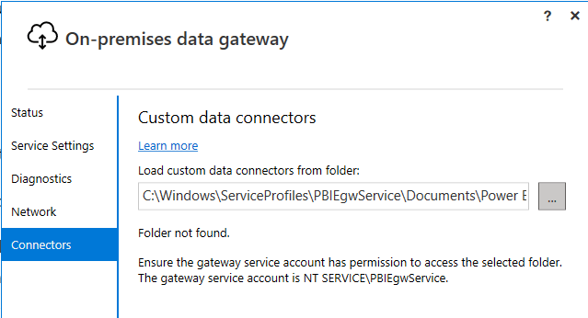Using custom connector in a Power BI gateway
Troubleshooting
There are a few scenarios in which you may face an issue when setting up the gateway. Here I explained them one by one;
- You cannot see the gateway listed when you go to your dataset setting. Most probably because you did not add all the data sources needed for that dataset. Go to Power BI Desktop and check whether you have added all data sources.
- Analysis Services Live Connection with gateway requires more configuration, which I explained in another article.
- Gateway has a logging system which can be helpful when an issue comes up. You can enable additional logging and access the gateway logs from the on-premises data gateway installed in the application.

Practical Implementation
Steps for using the Gateway:
- Download and install the gateway on a local computer(Standard Mode). https://www.microsoft.com/en-us/power-platform/products/power-bi/gateway

- Enter the Power BI service mail in the gateway and sign in.
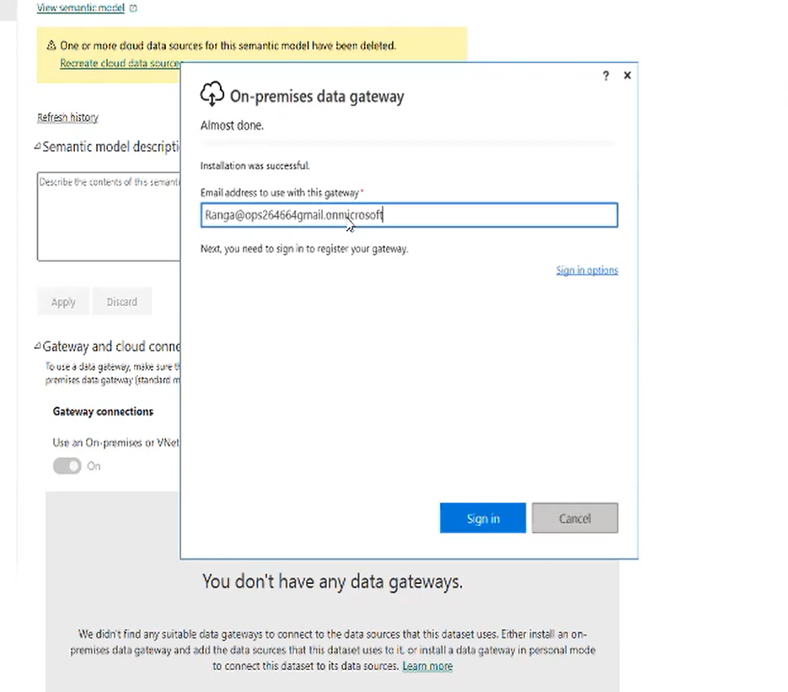

- Enter the gateway name and recovery key and configure.
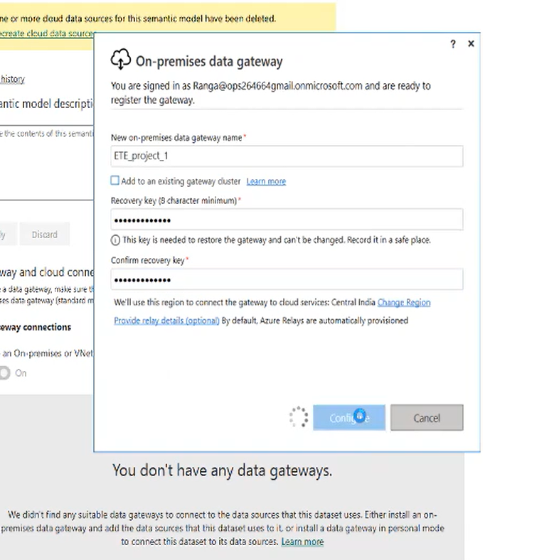

- Go to Power BI services. Click on the Semantic Model settings and Open Gateway and Cloud Connections.
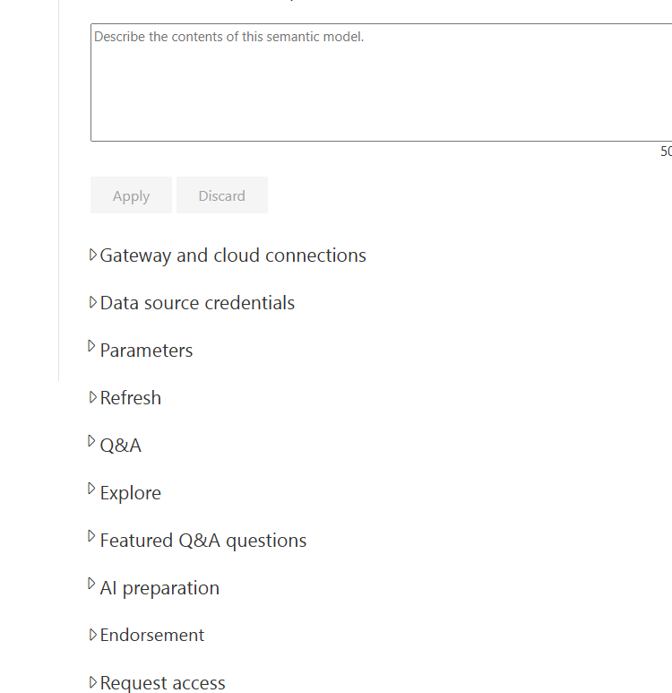

- Click on the drop down beside gear button.
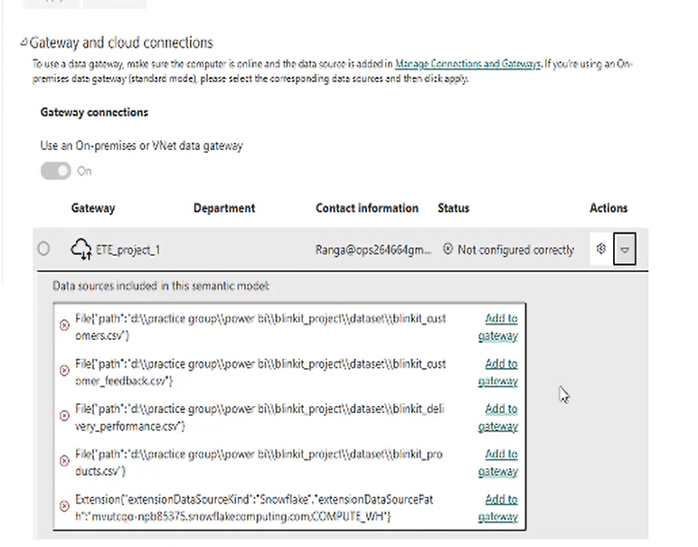
- Now you can see the multiple data sources in drop down. Click on “Add to gateway”.
- Fill the required credentials and Click on create.
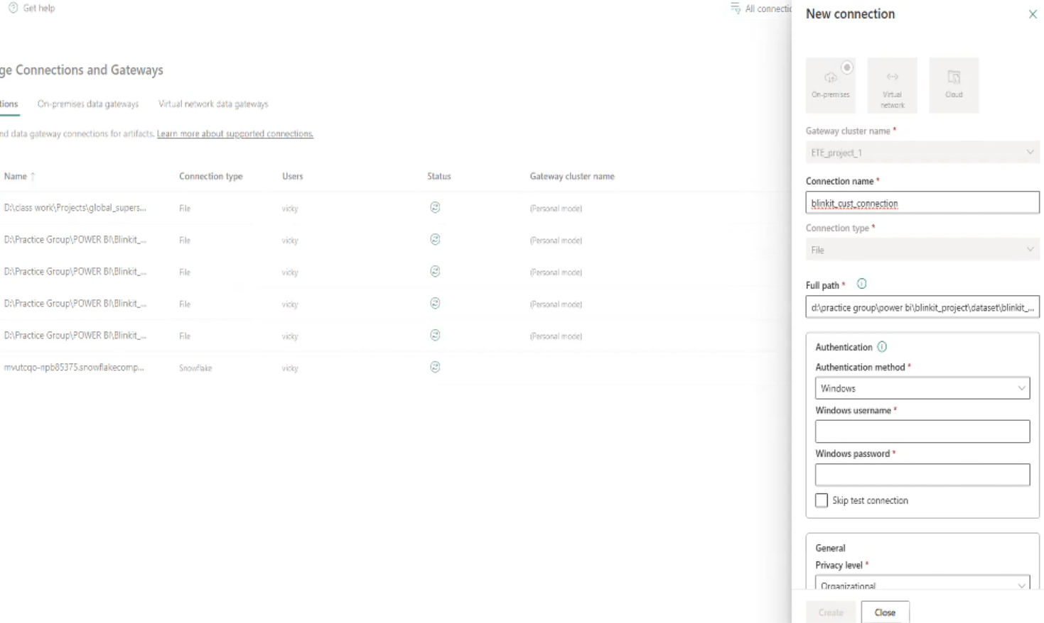

- Repeat the same for each on-premise data sources.

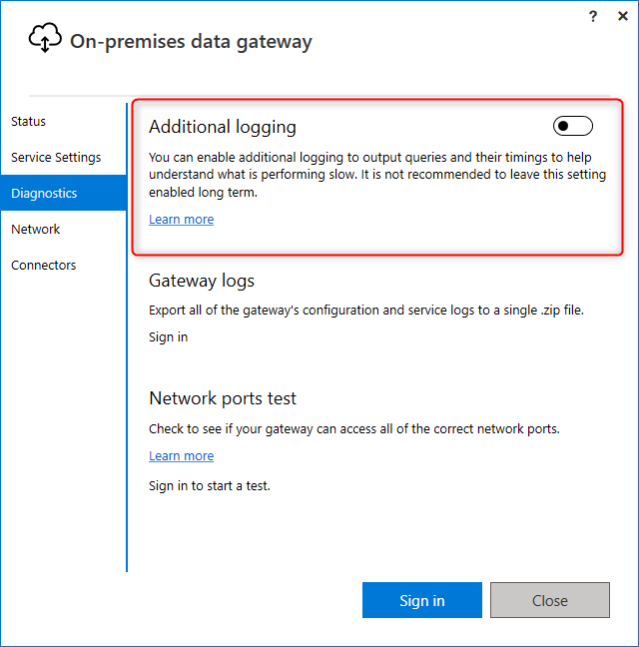Enabling additional logging in the Power BI gateway
- There are a few known issues with the on-premises gateway, which you can read more about them here: https://docs.microsoft.com/en-us/power-bi/service-gateway-onprem-tshoot
- There are a few known issues with the personal gateway, which you can read more about them here: https://docs.microsoft.com/en-us/power-bi/personal-gateway
Summary
In this section, you’ve learned about Gateway. The gateway connects the Power BI cloud-based dataset and the data source on-premises. You learned that gateway is only required for on-premises connections. There are two modes to install a gateway; personal and recommended (on-premises). You learned that the on-premises recommended gateway can serve more than one developer at a time and be used for Power BI, PowerApps, and a few other applications. It also supports multiple connection types.
We went through the installation and configuration of the gateway and connected one Power BI dataset to it. The key to using a gateway is to add all required data sources under it and then map them to the dataset.

